**TASK 2 – Conversation System**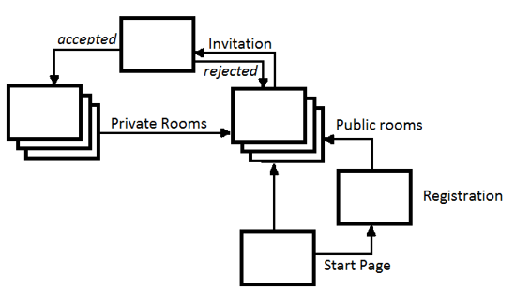

**Actors:**

|  |  |
| --- | --- |
| Actor (Name) | Actor (Description) |
| Registered User | Person who has previously registered |
| Guest | Person who is not registered |

**UseCases:**

|  |  |
| --- | --- |
| **Use Case** | Log in as a Guest |
| **Goal in Context** | Guest wants to join conversation in Public Room without account in system |
| **Preconditions** | No |
| **Success End Condition** | Entered chosen Public Room as Guest |
| **Failed End Condition** | Not entered chosen Public Room |
| **MAIN SUCCESS SCENARIO** | |
| 1. Guest press 'log in as a guest' | |
| 2. Guest chooses existing Public Room to enter | |
| **EXTENSIONS** | |
| n/a | |

|  |  |
| --- | --- |
| **Use Case** | Register |
| **Goal in Context** | Guest wants to possess an account in system |
| **Preconditions** | No |
| **Success End Condition** | Login and password stored |
| **Failed End Condition** | Login and Password not stored |
| **MAIN SUCCESS SCENARIO** | |
| 1. Guest press 'Register' | |
| 2. Guest enters login and password | |
| 3. Guest submits form | |
| **EXTENSIONS** | |
| 2a. Login is not unique | |
| 2a1. Popup is shown | |
| 2b. Password to simple | |
| 2b1. Popup is shown | |
| 3a. Guest aborts action | |

|  |  |
| --- | --- |
| **Use Case** | Log in as a Registered User |
| **Goal in Context** | Registered User wants to join conversation in Public Room using his account in system |
| **Preconditions** | No |
| **Success End Condition** | Entered chosen Public Room as guest |
| **Failed End Condition** | Not entered chosen Public Room |
| **MAIN SUCCESS SCENARIO** | |
| 1. Registered User press 'Log in' | |
| 2. Registered User enters login and password | |
| 3. Registered User submits form | |
| 4. Registered User chooses existing Public Room to enter | |
| **EXTENSIONS** | |
| 3a. Invalid login or password | |
| 3a1. Popup shown | |
| 4a. Registered User aborts action | |

|  |  |
| --- | --- |
| **Use Case** | Open additional Public room |
| **Goal in Context** | Guest or Registered User wants to join one more conversation in Public Room |
| **Preconditions** | Log in as Guest or log in as Registered User |
| **Success End Condition** | Entered chosen Public Room |
| **Failed End Condition** | Not entered chosen Public Room |
| **MAIN SUCCESS SCENARIO** | |
| 1. Registered User or Guest chooses existing Public room | |
| **EXTENSIONS** | |
| n/a | |

|  |  |
| --- | --- |
| **Use Case** | Invite user to Private room |
| **Goal in Context** | Guest or Registered User wants to offer other user a private conversation in Private Room |
| **Preconditions** | Log in as Guest or log in as Registered User |
| **Success End Condition** | Invitation sent |
| **Failed End Condition** | Invitation not sent |
| **MAIN SUCCESS SCENARIO** | |
| 1. Guest/Registered User press 'Invite user' | |
| 2. Guest/Registered User enters other user login | |
| 3. Guest/Registered User submits invitation | |
| **EXTENSIONS** | |
| 3a. Entered login does not refer an existing user | |
| 3a1. Popup shown | |
| 3b. Guest/Registered User aborts action | |

|  |  |
| --- | --- |
| **Use Case** | Accept invitation to Private room |
| **Goal in Context** | Guest or Registered User wants to accept an invitation to a private conversation in Private Room from other user |
| **Preconditions** | Log in as Guest or log in as Registered User |
| **Success End Condition** | Entered Private room |
| **Failed End Condition** | Not entered Private room |
| **MAIN SUCCESS SCENARIO** | |
| 1. Guest/Registered User press 'Accept invitation' | |
| **EXTENSIONS** | |
| n/a | |

|  |  |
| --- | --- |
| **Use Case** | Reject invitation to Private room |
| **Goal in Context** | Guest or Registered User wants to reject an invitation to a private conversation in Private Room from other user |
| **Preconditions** | Log in as Guest or log in as Registered User |
| **Success End Condition** | Invitation dialog closed and invitation rejected |
| **Failed End Condition** | Invitation dialog not closed or invitation rejection failed |
| **MAIN SUCCESS SCENARIO** | |
| 1. Guest/Registered User press 'Reject invitation' | |
| **EXTENSIONS** | |
| n/a | |